Social Media Influences on Presidential Elections

Charles Shewell
Department of Education
Sul Ross State University
ED 6383: Ed Tech Capstone
Dr. Jennifer Miller-Ray
March 3, 2023

ABSTRACT: This case study examines how digital literacies influence social media use for millennials in decision-making for presidential elections. Topics explored in this case study investigates citizenship trends in education, digital skills for citizenship, implications of citizenship for millennials in education, and social media trends. Social media has emerged as a main source of information and news, allowing for an informed citizenry. Considering that political news consumption is in relationship with social media usage, this study looks to find the influences that contribute to users voting choices. The goals of this study are to first provide an understanding of the influences of social media literacies for millennials in relation to government politics and presidential elections, the importance of digital citizenship in education, and contributing additional research towards a newer field of study.
INTRODUCTION
Our lives have changed in the ways we communicate, build relationships, learn, and work with the integration of digital technologies. Using the internet and technological tools, communication and informational consumption has not only reached higher speeds but reaches globally as well. Citizenship once focused on reading, writing, and arithmetic, as well as consumption of information through newspapers, radio, and news programming. Nowadays, information can be processed with the click of a button on handheld devices from anywhere. With this comes a new concept known as digital citizenship which involves categories such as participation, security, law, health, and commerce. These categories are a part of the literacies needed for responsible digital citizenship, that allow for the proper use of new technologies.
Technology and the internet have provided populations of people with the ability to access information and communication for political engagement. This is evident within the increased usage of social media on millennials. Millennials have the ability to spread their political opinions that reach more people with their voice than ever before through social media.
An extensive online search was conducted to locate a minimum of 10 articles for use in this literature review. Using keywords and topics such as digital citizenship, digital literacies, and digital skills, I was able to cipher through online search engines using Google Scholar and the Sul Ross State University library where I selected recent peer reviewed research. Upon looking over the articles selected, I found multiple research articles shared citations from previous research, leading me to use this research as well. Although some of the conducted research is not as recent, I believe the research to be foundational pieces in which groundwork in digital citizenship is laid, therefore holds importance in its use for this review. I will explore the influence of social media on millennials for Presidential elections and how millennials use social media to share their political beliefs.
LITERATURE REVIEW
SYNTHESIS
The studies within this review suggest that digital citizenship is made up of skills known as digital literacies entailing nine key factors. These factors are digital access, digital commerce, collaboration, etiquette, digital welfare, digital law, privacy, and digital responsibilities. While these terms are commonly used in social norms and practice, as well as law, Pangrazio (2021) suggested citizenship and literacy are not yet established assets. As technological tools and spaces continue to entangle itself into daily life, Swarts (2020) believes technology becomes more complicated, as does the term digitally literate. To produce digital citizens, populations need a skillset, or digital literacy skills, and characteristics to establish competency in digital citizenship. The sphere in which digital citizenship is viewed changes with new communication technology, as recommended by Ali Simsek (2013). Modern literacies emerge with different mediums such as social media, the internet, and mobile technology. For efficient and responsible citizenship, Simsek and Simsek (2013) posed that structural factors for societal life require a set of practical literacy skills. Isman (2014) proposes that there are specific characteristics one must have for digital citizenship, which include an understanding of cultural and societal issues in relation to technology, while demonstrating respectable behavior using safe and supportive collaboration when learning. Because digital literacy is not an established term, Prasetiyo (2021) recommends this term be interpreted as a set of required abilities practiced within digital environments, as being informed is considered above all. The learning of these skills allows for users to obtain the knowledge necessary for the promotion and protection of students while engaged on and offline.
The development of digital literacies for becoming responsible digital citizens is crucial as educational leaders play a pivotal role in students’ use of technology. Peart (2022) believed the acquired skills needed for active and responsible participation in societal issues is a role education should play, where students can be empowered as digital citizens. Peart (2022) also suggested that digital inclusion could provide improvements to digital services, which create equal opportunities in digital literacy for all of society. With technology continuously evolving and being integrated into education, Swarts (2020) recommended educational and institutional systems have a need for adaptation in terms of values and practice for the education of digital citizenship. For the cultivation of informed future generations, Peart (2022) suggested educational systems place a focus on student skill development that allows for learners to be aware and critical of their responsibilities in a digital society. Something for educational leaders to be aware of when integrating digital citizenship is the potential harms with technology in the digital society. Manzouli (2019) listed out harms such as cyberbullying and grooming, which from a policy viewpoint can be difficult to understand, while Baydar (2022) believes it is an important responsibility of educational leaders for guidance towards a transition to a digital society that reduces the harmful effects and increases benefits of technology. For the minimization of harm, Capuno (2022) recommended educational systems should develop and integrate a relevant curriculum and organization should be based off published research. Through a research-based curriculum and appropriate technology use, Baydar (2022) stated that students will avoid being affected by the harm of technology and its addictions.
As students develop digital literacies through educational technology use, global engagement and participation become key elements in a digital democratic society. Pangrazio (2021) explains that the facilitation of civic participation when using digital platforms has a significant impact on democratic politics, but Prasetiyo (2021) suggested that before this can happen, educational systems must create strategies for the response of problems presented in technology. Through Information and communicative technologies (ICT) younger generations have the capabilities for the mobilization of organized supporters in digital political environments and has become more and more apparent in recent elections (Swarts, 2020). For example, the Obama administration harnessed the power of the internet for the gain of young voters’ attention. Maguth (2012) suggested that newer technologies were used during the presidential race for the engagement of young voters and was unlike previous candidates as the Obama team found technologies that organized the mobilization of his younger supporters. Maguth (2012) also suggested that this was precedent setting for future campaigns. ICTs are not only used for political issues involving elections, but global politics that require humanity across all borders. Swarts (2020) explained that political issues such as ecological catastrophes and refugee crisis, along with any issue that benefits from the mobilization of digital societies can provide opportunities for the practice of digital citizenship.
Lee and Xenos (2019) stated that the widespread availability of news and political information on social media might be considered idea for improving citizens’ knowledge of current events given that most people who get news via social media do so while using social media for purposes other than news gathering. Users scrolling through their feeds often come across posts from other users or trending topics that essentially infiltrate their digital space, leaving the possibility for political news to influence them. News consumption on social media includes not only purposeful exposure, but incidental exposure to political content while using social media for other purposes, as explained by Lee and Xenos (2019). Through the use of social media as a campaign tool, political reach has drastically expanded since the Obama campaign. Jensen and Schwartz (2022) claim that the first breakthrough for social media was the Barack Obama victory in the 2008 presidential election. Social media did not necessarily affect the election in terms of influencing a voter’s choice, but it did affect the voter turnout. Aral and Eckles (2019) described social media manipulating the effect of voter turnout through targeting younger voters that could change the overall results. Still in its infancy, this topic does not necessarily have immense research analysis, but Aral and Eckles (2019) believe that social media effects are measurable, while Jensen and Schwartz (2022) propose studies be focused on new media as campaign tools while evaluating their success in terms of impact rather than dialogue. As mentioned earlier, political news media can be happened upon accidentally too, so as proposed by Lee and Xenos (2019) we should examine how non-political social media use influences political knowledge as well.
RESEARCH QUESTION
Following my literature review, I have formulated a question for research asking: How do social media literacies influence millennial decision-making in presidential elections?
METHODOLOGY
This study followed research techniques involving a mixed methods approach by asking questions over topics such as social media usage and political posts on social media platforms that allow for a more in-depth investigation of political influences on the millennial generation through a variety of dichotomous questions and questions that can calculate sentiment through a structured Likert Scale. The questionnaire was sent out electronically to current students and faculty of Sul Ross State University and made available for a period of two weeks. After the two week period ended, this data was then collected in the Qualtrics program and analyzed for determining relationships between social media use and political influence. All participant responses were recorded with the consent of the respondents.

Interview Questions
- Are you between the ages of 18 and 40 years of age?
- What is your sex?
- Which social media applications do you regularly use?
- How many hours a day do you spend on social media?
- Do you follow government officials on social media?
- How often do you comment, post, or discuss government and politics on social media?
- How much of what you see on social media is related to government or politics?
- How would you describe the political viewpoints of those you follow on social media?
- How would you describe the political viewpoints of those that follow you on social media?
- What best describes you when viewing political posts on social media?
- When discussing politics on social media, are the conversations generally civil or uncivil?
- Are these discussions on social media informative or noninformative?
- How do these political discussions on social media effect your opinion?
- When one of your friends’ posts something political on social media that you disagree with, how do you respond?
- Best describe the following statement: government and political posts on social media effect the way I vote or will vote in the future.
RESULTS
At the conclusion of the data collection, a total of 35 participants completed the survey. The respondents were described as 22% of the participants were between the ages of 18 to 25, 39% were between 26 and 40, 28% were between 41 and 55 years of age, and 11% are older than the age of 56, with 78% of the participants being female, 19% male, and 3% offered not to answer. Of the participants, Table 1 describes the social media platforms used, while Table 2 describes the platforms used of the 18 participants that stated they follow government officials.
Table 1
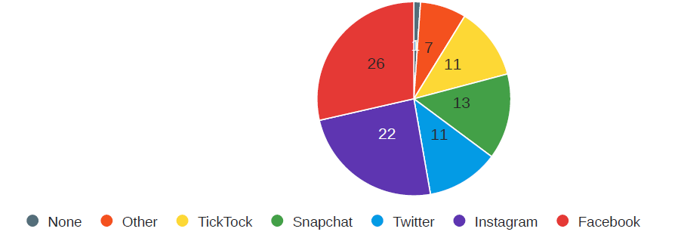

Table 2
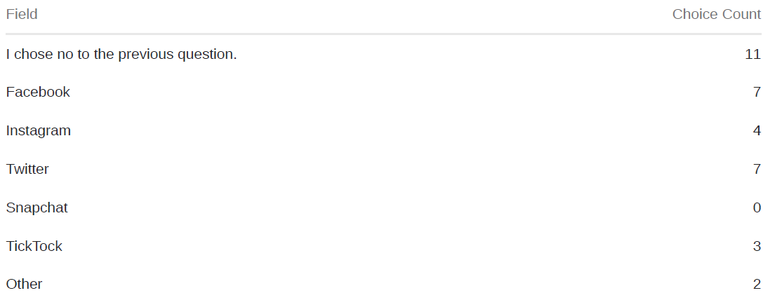
While 18 of the 34 participants stated that they rarely to never post, comment, or discuss politics on social media platforms, 40% of the participants described often seeing political social media posts on their feeds. Table 3 describes the viewpoints of those the participants follow on social media in terms of politics, while Table 4 shows the viewpoints of those that follow the participants.
Table 3
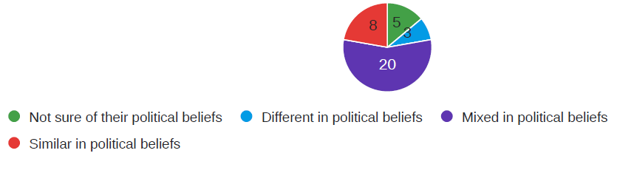
Table 4
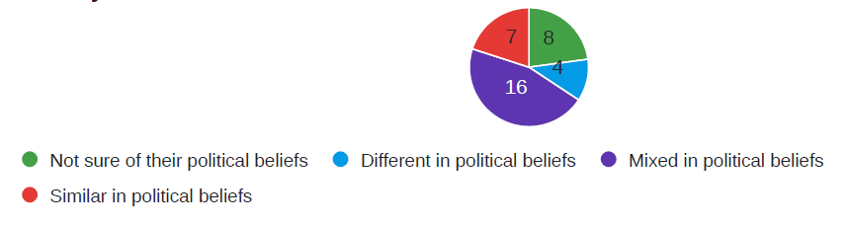
Table 5 explains participant viewpoints when interacting with political posts on their social media platforms, while Table 6 shows participant views of civility when discussing government or politics on their social media platforms.

Table 5
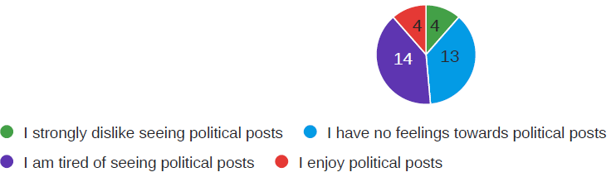
Table 6
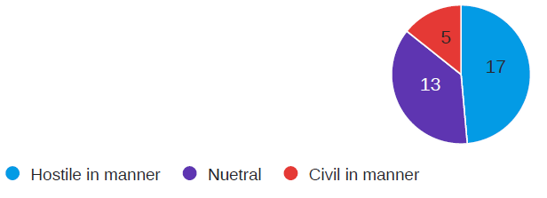
DISCUSSION
The outcomes of this study provide descriptive insight into the relationship between social media influences and the political viewpoints of multiple generations. The results must be interpreted with caution due to the limitations of the current study. After a reflection of the research process, the limitations, interpretation of results, and recommendations for future research will be discussed.
The analysis of social media influences on political voting for the millennial generation shows no evidence of influence on millennial decision making for political elections, however there are indications that there is a relationship between the two. Approximately 60% of the participants stated a positive or negative feeling when seeing political posts on their social media feeds, while about 49% of total participants find political discussions on social media to be hostile. This coincides with Lee and Xenos (2019) as they stated that previous research studying relationships between social media and political knowledge fail to observe a positive relationship. Of the 35 participants, 48.65% believe that political posts are informative, suggesting that Lee and Xenos (2019) were correct in questioning if social media helps users learn about politics, as well as reflecting that social media influence can be measured, as stated by Aral and Eckles (2019).
The generalizability of the results is limited by the small sample size used in this study which can hinder statistical measurements. For furthering this study, a larger sample size will be needed. This would need to include more than just the student body at Sul Ross State University. This case study would need to include a random selection of millennials from locations across the country for a true national perspective. Another limitation is the time constraints of the case study as time to conduct this study was shortened to a two-week period for SRSU students and faculty were open to completing the survey.
Future research and questions would focus on a more in-depth investigation of social media use, political engagement through social media platforms, and the creation of a point scale to determine rates of political engagement and influences. Also included in future research will be an investigative look into social media algorithms for factoring how often political posts are placed on user feeds to strengthen the influence.
CONCLUSION
In this study, we examined the influence social media holds on millennial decision making for political elections. Political influences were investigated through comparing political discussions on social media and the viewpoints of users. After examination, the data analysis concludes that further research must be completed for a proper testing of the hypothesis. While failing to show true influence on presidential elections, this study allowed for a basic look into the relationship between social media and user viewpoints when interacting with political discussions online. Due to some limitations, it is possible that outcomes could differ or strengthen the measurements over a longer period of time, as well as covering a larger population. Future research should consider further investigation into social media algorithms as they factor into political posts placed on user feeds, as well as providing a survey with more in-depth questioning. Regardless, the results of this study point towards a need for deeper understanding of social media influences, online political campaign strategies, and the effects on user viewpoints.
REFERENCES
Aral, S., & Eckles, D. (2019). Protecting elections from social media manipulation. Science, 365(6456), 858–861. https://doi.org/10.1126/science.aaw8243
Baydar, F. (2022). The Role of Educational Leaders in the Development of Students’ Technology Use and Digital Citizenship. Malaysian Online Journal of Educational Technology, 10(1), 32–46. https://doi.org/10.52380/mojet.2022.10.1.367
Capuno, R., Suson, R., Suladay, D., Arnaiz, V., Villarin, I. & Jungoy, E. (2022). Digital citizenship in
education and its implication. World Journal on Educational Technology: Current Issues. 14(2),
426-437. https://doi.org/10.18844/wjet.v14i2.6952
Isman, A, Canan Gungoren, O., & Sakarya University, Faculty of Education. (2014, January).
Digital Citizenship. The Turkish Online Journal of Educational Technology, 13(1), 73-77.
Jensen, J. L., & Schwartz, S. A. (2022). Introduction: A Decade of Social Media Elections. Social Media + Society, 8(1). https://doi.org/10.1177/20563051211063461
Lee, S., & Xenos, M. (2019). Social distraction? Social media use and political knowledge in two U.S. Presidential elections. Computers in Human Behavior, 90, 18–25. https://doi.org/10.1016/j.chb.2018.08.006
Maguth, B. M. (2012). Investigating Student Use of Technology for Engaged Citizenship in A Global Age.
Education Sciences, 2(2), 57-76. https://doi.org/10.3390/edusci2020057
Manzuoli, C., Sanchez, A., & Bedoya, E. (2019). Digital Citizenship: A Theoretical Review of the Concept and Trends. The Turkish Online Journal of Educational Technology, 18(2), 10–18.
Metaxas, P. T., & Mustafaraj, E. (2012). Social Media and the Elections. Science, 338(6106), 472–473. https://doi.org/10.1126/science.1230456
Pangrazio, L., & Sefton-Green, J. (2021). Digital Rights, Digital Citizenship and Digital Literacy: What’s the Difference? Journal of New Approaches in Educational Research, 10(1), 15. https://doi.org/10.7821/naer.2021.1.616
Peart, M., Cubo-Delgado, S., & Gutiérrez-Esteban, P. (2022). Exploring the Role of Digital and Socio-civic Skills for Promoting Youth Participation and Digital Citizenship. European Journal of Educational Research, 11(2), 697–709. https://doi.org/10.12973/eu-jer.11.2.697
Prasetiyo, W. H., Naidu, N. B. M., Tan, B. P., & Sumardjoko, B. (2021). Digital citizenship trend in educational sphere: A systematic review. International Journal of Evaluation and Research in Education (IJERE), 10(4), 1192. https://doi.org/10.11591/ijere.v10i4.21767
Simsek, A., & Simsek, E. (2013). New Literacies for Digital Citizenship. Contemporary Educational
Technology, 4(2). https://doi.org/10.30935/cedtech/6097
Swarts, G. (2020). Re/coding Global Citizenship: How Information and Communication Technologies have Altered Humanity. . . and Created New Questions for Global Citizenship Education. Research in Social Sciences and Technology, 5(1), 70–85.https://doi.org/10.46303/ressat.05.01.4

